**7. Jesus forgives Peter**

**Reading:** John 21:15-17

When they finished eating, Jesus said to Peter, “Simon, son of John, do you love me more than these other men love me?”

Peter answered, “Yes, Lord, you know that I love you.”

Then Jesus said to him, “Take care of my lambs.”

Again, Jesus said to him, “Simon, son of John, do you love me?”

Peter answered, “Yes, Lord, you know that I love you.”

Then Jesus said, “Take care of my sheep.”

A third time Jesus said, “Simon, son of John, do you love me?”

Peter was sad because Jesus asked him three times, “Do you love me?” He said, “Lord, you know everything. You know that I love you!”

Jesus said to him, “Take care of my sheep.”

**Thought about the reading**

The story in this reading happened after Jesus had risen from the dead on Easter Sunday. Peter and some other followers decided to go fishing on Lake Galilee. They were fishing all night but caught nothing. Then Jesus appeared on the shore and told them to try again. This time they caught lots of fish. They had breakfast with Jesus on the beach.

After breakfast, Jesus talked to Peter. When Jesus was arrested, before he was crucified, Peter said three times that he did not know him. He let Jesus down. He must have felt very sad and ashamed. So, three times Jesus asked him if he loved him. Jesus forgave him, and asked him to look after his followers, his sheep. It was a new start for Peter.

Everyone does things wrong sometimes and we might feel that we have let Jesus down like Peter did. If we tell Jesus we are sorry, he will also forgive us. We too can have a new start.

**Prayer**

Lord Jesus, we are sorry for the things we do that make you sad and let you down. Please forgive us and help us to start again, like Peter did.

Amen

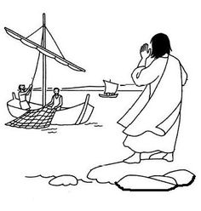

**Cambridge Causeway**

Summer 2021

Bible Study notes

**Eyewitnesses**

**7. Jesus forgives Peter**

By Chrissy Cole